How to check in as a patient
To meet with your provider on Doxy.me, first you need to use Chrome, Firefox, or Safari browser. A webcam and microphone are also required.
Your provider will call you with their personalized room link. It should look like doxy.me/YourDrsName.
To “check-in”:
- Type your provider's room address into your web address bar(e.g. https://doxy.me/room-name)

2.Enter your name, click "Check-In"
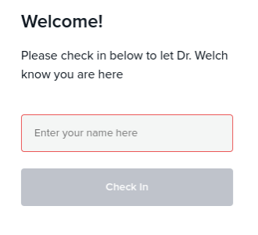
3. You are now in your provider's waiting room. Wait for your provider to start the call
